Paper Number:
(For office use only)

TITLE OF THE RESEARCH PAPER (Times New Roman, 14pt, Bold, Upper Case, Center-Aligned)

Introduction (Times New Roman, 12pt, Bold, Left-Aligned)

An extended abstract is a more detailed summary of a research paper, providing a comprehensive overview of the study including key elements like the research question, methodology, results, and conclusions, but in a concise format that is longer than a standard abstract. The extended abstract must be written in clear, grammatically accurate English.

The maximum word limit excluding tables, figures, and references is 1500 words.

Please DO NOT change the paper formatting: Paper size – A4, Margins – Left 1.5 inches and all others 1 inch, Line spacing – single, single column, Font style – Times New Roman, 12pt, Text justified, Page number – Bottom centered.

The introduction section should clearly state the research problem, provide relevant background information, highlight the significance of the study, briefly review key literature related to the topic, and outline the research objectives or questions.

Methodology

The methodology must be clearly stated and described sufficiently in detail or with references.

Results and Discussion

The authors should present the results of the study and the discussion should focus on how the research was instrumental in achieving the objectives.

The findings and arguments of the work should be explicitly described and illustrated. Supporting tables, figures, and images of the results may also be included.

All the tables, figures, and equations should be left aligned. Tables, figures, and equations should be numbered (see Figure 1 or Table 2 for an example). A table or figure caption should be placed above the figure or table.

The word “Table”, “Figure” and the associated number in the caption should be in Times New Roman, 12pt, bold. Then, present the caption in plain text in Times New Roman, 12pt with only the initial letter and any proper names capitalized.

Cite the table, figure, or image if it–or its data–came from a source, using APA style. The word “Source” should be in plain text Times New Roman, 11pt.

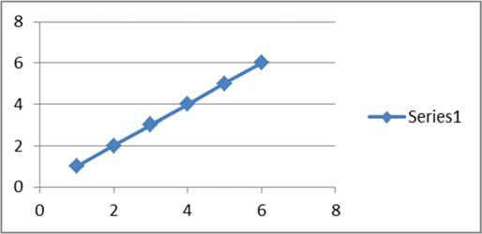
Figure 1: A nice linear plot

Source: If needed

Table 2: Tabulated data of the study

Label | Label | Label
Source: Only if this table is taken from another source, mention it here

Equations should be presented as editable text using the equation editor and numbered consecutively within the document. Avoid converting equations into images.

$y_{i}=β_{0}+β_{1}X_{i}+u_{i}$ ……………………………………………………………….(1)

Conclusion

Conclusion should include the summary and generalization of the results and contributions and limitations of the work.

Acknowledgement

Any acknowledgement that authors wish to make for the support received for the research study.

References

The references should only include published material accessible to the public. Proprietary information such as internal reports may not be cited.
The references should follow APA (latest edition) style and carefully check for completeness, accuracy, and consistency. The style guideline can be found at
https://uom.lk/sites/default/files/lib/files/APA_7th_User_Guide_2021-Web_2_0.pdf.

